A Project Report on

**Arduino Based Sensing System for**

**Air Quality Monitoring**

Submitted to the Department of Information Technology

**For the partial fulfilment of the degree of B.Tech in Information Technology**

**by**

Gautam Kumar (Reg. No. : 510816018)

Ravi Kumar (Reg. No. : 510816029)

Vishal Kumar Vishwakarma (Reg. No. : 510816038)

B.Tech, 4th year

**Under the supervision of**

**Associate Prof. Tuhina Samanta**



## **Department of Information Technology**

**Indian Institute of Engineering Science and Technology, Shibpur**

**Aug-Dec 2019**



## **Department of Information Technology**

**Indian Institute of Engineering Science and Technology, Shibpur**

**CERTIFICATE**

**This is to certify that the work presented in this report entitled “Arduino Based Sensing System For Air Quality Monitoring”, submitted by Gautam Kumar, Ravi Kumar & Vishal Kumar Vishwakarma having the examination roll number 510816018, 510816029 & 510816038 respectively, has been carried out under my supervision for the partial fulfilment of the degree of Bachelor of Technology in Information Technology during the session 2019-20 in the Department of Information Technology, Indian Institute of Engineering Science and Technology, Shibpur.**

|  |  |
| --- | --- |
| **---------------------------------------------------**  **Name of Supervisor** | **-----------------------------------------------------**  **Head Of the Department** |
| **Prof. Tuhina Samanta** | **Dr. Hafizur Rahaman** |
| **Department Of Information Technology** | **Department Of Information Technology** |
| **Indian Institute Of Engineering Science & Technology, Shibpur** | **Indian Institute Of Engineering Science & Technology, Shibpur** |

**ACKNOWLEDGMENT**

We are deeply indebted to **Prof. Tuhina Samanta** for his inspiration, and guidance throughout our project work which has been conducted at **Indian Institute of Engineering Science and Technology, Shibpur**. His advice on topics have benefitted and enriched our knowledge in several ways. We are grateful to him for being very supportive and letting us pursue our interests outside of academics, and encouraging us to read to learn and read widely.

We had many insightful discussions with him, which have improved our understanding of various topics. His dynamism, vision, sincerity and motivation have deeply inspired us. It was a great privilege and honour to work under his guidance.

We are happy to be a part of the information technology department, which is an excellent environment for research. Nothing could have been possible without its warm and cosy environment. We are obliged for this opportunity.

**--------------------- --------------------------- ---------------------------**

**Gautam Kumar Ravi Kumar Vishal Kumar Vishwakarma**

**CONTENTS**

1. **Introduction**
2. **Air Quality Parameters**

2.1 Carbon Monoxide(CO)

2.2 Carbon Dioxide

2.3 Smoke

2.4 LPG

2.5 Temperature & Humidity

1. **Air Quality Monitoring System**

2.1. Required Components

2.2 Circuit Diagram and Explanation

2.3 Block Diagram & Working

2.4 Pseudo Code

1. **PROPOSED AIR QUALITY MONITORING SYSTEM DESIGN**

4.1 Air Quality Monitoring Equipment

4.1.1 Arduino Uno R3 microcontroller

4.1.2 MQ135 Gas Sensor

1. **Results**
2. **Future Aspects**
3. **Conclusion**

**ABSTRACT**:The level of pollution has increased with times by lot of factors like the increase in population, increased vehicle use, industrialization and urbanization which results in harmful effects on human well being by directly affecting health of population exposed to it. In order to monitor quality of air, a Wireless sensor network (WSN) based new framework is proposed which is based on data acquisition and transmission. The parameters of the environment to be monitored are chosen as temperature, humidity, volume of CO, volume of CO2, detection of leakage of any gas - smoke, alcohol, LPG. The values of these parameters are displayed by using LCD Screen attached with Arduino where they are being monitored. The value of Air Quality index are shown on the display. CO, a dangerous parameter is monitored with an extra precaution.

**1. Introduction:**

**1.1 Air Pollution Problem**

Air Pollution is the biggest problem of every nation, whether it is developed or developing. Health problems have been growing at faster rate especially in urban areas of developing countries where industrialization and growing number of vehicles leads to release of lot of gaseous pollutants. Harmful effects of pollution include mild allergic reactions such as irritation of the throat, eyes and nose as well as some serious problems like bronchitis, heart diseases, pneumonia, lung and aggravated asthma. According to a survey, due to air pollution 50,000 to 100,000 premature deaths per year occur in the U.S. alone.Various kinds of anthropogenic emissions named as primary pollutants are pumped into the atmosphere that undergoes chemical reaction and further leads to the formation of new pollutants normally called as secondary pollutants. For instance, according to the Fifth Assessment Report of the Intergovernmental Panel on Climate Change (IPCC), nearly all climate-altering pollutants either directly or indirectly (by contributing to secondary pollutants in the atmosphere) are responsible for health problems . Almost every citizen spends 90% of their time in indoor air. Outdoor air quality of the cities of developed countries improved considerably in recent decades. In contrast to this, indoor air quality degraded during this same period because of many factors like reduced ventilation, energy conservation and the introduction to new sources and new materials that cause indoor pollution. The design of buildings for lower power consumption resulted in decrease of ventilation which further decreases the quality of air inside the building. This increases the need for indoor air quality (IAQ) monitoring Due to this fact and use of new building materials, IAQ often reaches to unacceptable levels.

**2.AIR QUALITY PARAMETERS**

The important parameters that are considered in the proposed framework include:

**2.1 Carbon monoxide gas**

CO is odourless, colourless, tasteless and highly poisonous gas. It is released when fuel in engine does not burn properly and road traffic is the primary source of 91% of all CO emissions. In addition, after combining with the haemoglobin of blood, it forms carboxyhaemoglobin (HbCo) which leads to reduction in oxygen carrying capacity of blood thus causes hypoxia. Human health is largely in danger with the exposure to 100ppm or more. Continuous exposure of CO even at low levels can cause depression, confusion, and memory loss. Carboxyhemoglobin can be reverted to haemoglobin but the recovery process is slow because of the stability of HbCo complex. The optimum treatment for CO poisoning although remains controversial, but providing hyperbaric oxygen therapy is considered as a treatment whether or not it provides necessary results. Half-life of CO gets shortens from 320 minutes to 80 minutes on normal air by managing oxygen via non-rebreathe mask.

**2.2 Carbon dioxide gas**

CO2 is colourless, odourless gas and non-combustible gas. Moreover, it is considered under the category of asphyxiate gases that have capability of interfering the availability of oxygen for tissues. It is certified study that if the oxygen is unavailable for 3 to 5 minutes, it can cause brain damage or death. Many times, occupant generated CO2 act as a substitute for measurement of IAQ. The requirement of outdoor air can be easily predicted by the content of CO2 and according to the guidelines of ASHRAE CO2 levels must be less than 1000ppm. Generally CO2 levels of outdoor air are under 350ppm.

**2.3 Smoke**

About 1 million people are in habit of tobacco smoking globally of which majority population is from developing countries . Every year nearly 4.9 million people died due to smoking according to 2007 report . In addition, second hand smoke is serious threat to the health of people of all age’s causes 41000 deaths each year.

**2.4 LPG**

Liquefied petroleum gas (LPG) is an odourless and colourless liquid which evaporates readily into a gas. Leakage is normally detected by adding an odorant into it. It is considered under the category of highly flammable gases and it can be classified as a carcinogen and mutagen if Butadiene content is more than 0.1%. LPG may leak in the form of a gas or a liquid. If it leaks in the form of a liquid it evaporates quickly and will eventually form large cloud of gas in air which is relatively heavier than air thus drops to the ground. Whereas, LPG vapours travel along the ground for a long distance and gets collected in drains or basements. Gas leads to burn or explode after getting in touch with a source of ignition.

**2.5 Temperature and humidity**

Measurement of temperature is important for safety of people and affects our life skills. Greenhouse effect can be monitored by measuring temperature and comparing temperature changes from historical to present time especially since the industrial revolution using climate data. Humidity is a type of gas that protects us from UV rays from the sun and helps trap heat on Earth, thereby making the climate on Earth, a pleasant one for living. But as humidity increases, the warmth on Earth also increases which makes our life uncomfortable. Humidity is essential for various storage and food processing facilities.

**3. Air Quality Monitoring System**

In this project we are going to make an **Arduino Based Air Quality Monitoring System** in which we will **monitor the Air Quality over LCD Screen** and will trigger an alarm when the air quality goes down beyond a certain level, means when there are sufficient amount of harmful gases are present in the air like CO2, CO, smoke, alcohol. It will show the air quality in PPM on the LCD and as well as on webpage so that we can monitor it very easily. We are using MQ135 sensor which is the best choice for monitoring Air Quality as it can detect most harmful gases and can measure their amount accurately. In this project, you can monitor the pollution level from anywhere using your computer or mobile.

**3.1 Required Components:**

→ MQ135 Gas sensor

→ Arduino Uno

→ 16X2 LCD

→ Breadboard

→ 10K potentiometer

→ 1K ohm resistors

→ 220 ohm resistor

### **3.2 Circuit Diagram and Explanation:**

### First of all we will connect the MQ135 Sensor with Arduino.

### -Connect the VCC and the ground pin of the sensor to the 5V and ground of the Arduino and the Analog pin of sensor to the A0 of the Arduino.

1. Now we connect LCD With the Arduino.

he connection of LCD are as follows-

* Connect pin 1 (VEE) to the ground.
* Connect pin 2 (VDD or VCC) to the 5V.
* Connect pin 3 (V0) to the middle pin of the 10K potentiometer and connect the other two ends of the potentiometer to the VCC and the GND. The potentiometer is used to control the screen contrast of the LCD. Potentiometer of values other than 10K will work too.
* Connect pin 4 (RS) to the pin 12 of the Arduino.
* Connect pin 5 (Read/Write) to the ground of Arduino. This pin is not often used so we will connect it to the ground.
* Connect pin 6 (E) to the pin 11 of the Arduino. The RS and E pin are the control pins which are used to send data and characters.
* The following four pins are data pins which are used to communicate with the Arduino.

Connect pin 11 (D4) to pin 5 of Arduino.

Connect pin 12 (D5) to pin 4 of Arduino.

Connect pin 13 (D6) to pin 3 of Arduino.

Connect pin 14 (D7) to pin 2 of Arduino.

* Connect pin 15 to the VCC through the 220 ohm resistor. The resistor will be used to set the back light brightness. Larger values will make the back light much more darker.
* Connect pin 16 to the Ground.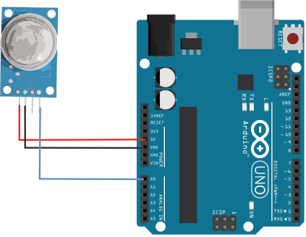

Fig 1.0 Connection of MQ135 with Arduino.

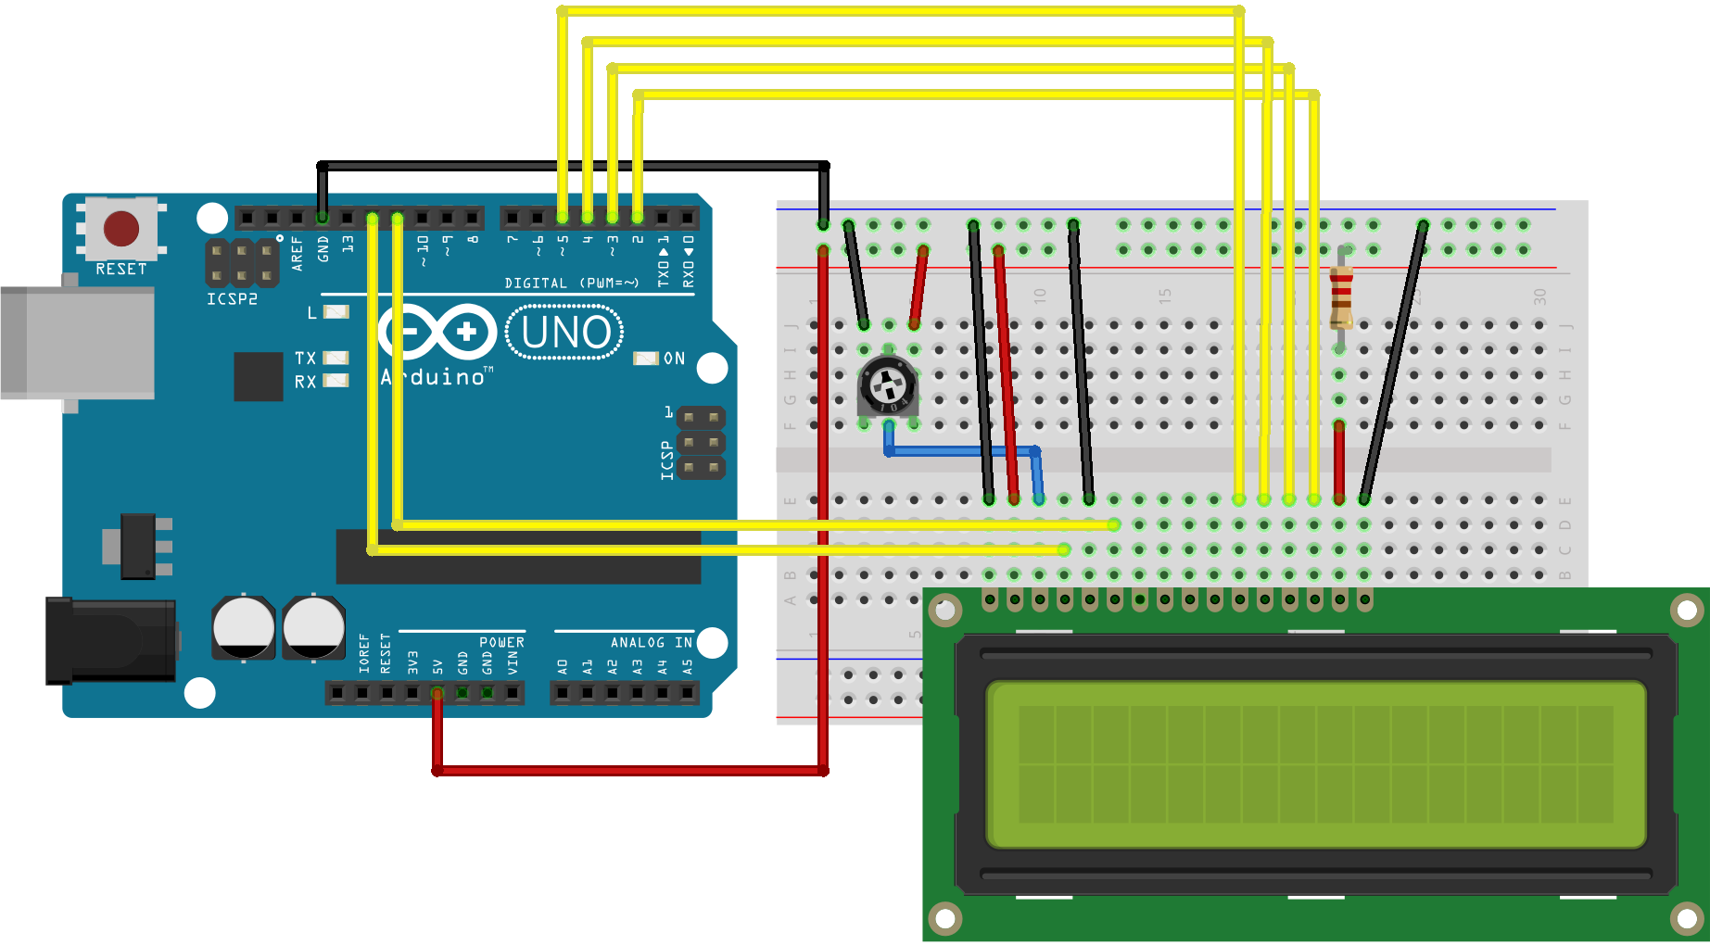

Fig 1.1 Connection of LCD with Arduino.

### **3.3 Block Diagram & Working:**

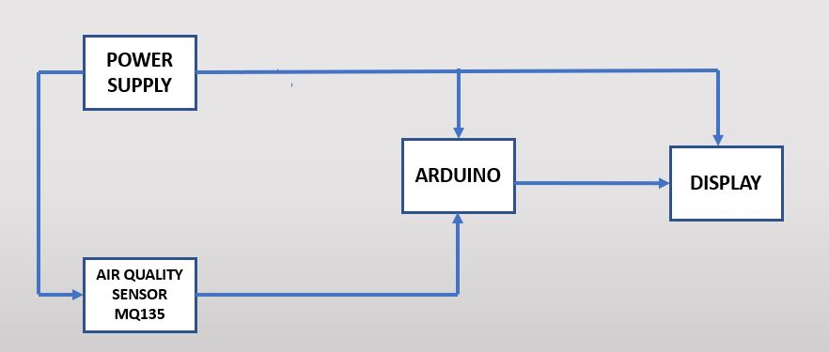

Fig 1.3 Block Diagram

The MQ135 sensor can sense CO2, alcohol, Benzene, smoke, NH3 and some other gases, so it is a perfect gas sensor for our **Air Quality Monitoring Project**. When we will connect it to Arduino then it will sense the gases, and we will get the Pollution level in PPM (parts per million).

Sensor was giving us value of 100-110 PPM when there was no gas near it and the safe level of air quality is 350 PPM and it should not exceed 1000 PPM. When it exceeds the limit of 1000 PPM, then it starts cause Headaches, sleepiness and stagnant, stale, stuffy air and if exceeds beyond 2000 PPM then it can cause increased heart rate and many other diseases.

When the value will be less than 1000 PPM, then the LCD will display “Fresh Air”. Whenever the value will increase 1000 PPM, then the buzzer will start beeping and the LCD and webpage will display “Poor Air, Open Windows”. If it will increase 2000 then the buzzer will keep beeping and the LCD and webpage will display “Danger! Move to fresh Air”.

**3.4 Pseudo Code:**

**#include <LiquidCrystal.h>**

**int sensorValue;**

**const int rs = 12, en = 11, d4 = 5, d5 = 4, d6 = 3, d7 = 2;**

**LiquidCrystal lcd(rs, en, d4, d5, d6, d7);**

**void setup(){ lcd.begin(16, 2);**

**Serial.begin(9600); // sets the serial port to 9600**

**}**

**void loop(){sensorValue = analogRead(0); // read analog input pin 0**

**Serial.print("AirQua=");**

**Serial.print(sensorValue, DEC); // prints the value read**

**Serial.println(" PPM");**

**lcd.setCursor(0,0);**

**lcd.print("ArQ=");**

**lcd.print(sensorValue,DEC);**

**lcd.print(" PPM");**

**lcd.println(" ");**

**lcd.print(" ");**

**delay(100); // wait 100ms for next reading**

**}**

**4. PROPOSED AIR QUALITY MONITORING SYSTEM DESIGN**

The proposed Air Quality Monitoring System is a 2 tier system as shown in Fig.2.0.

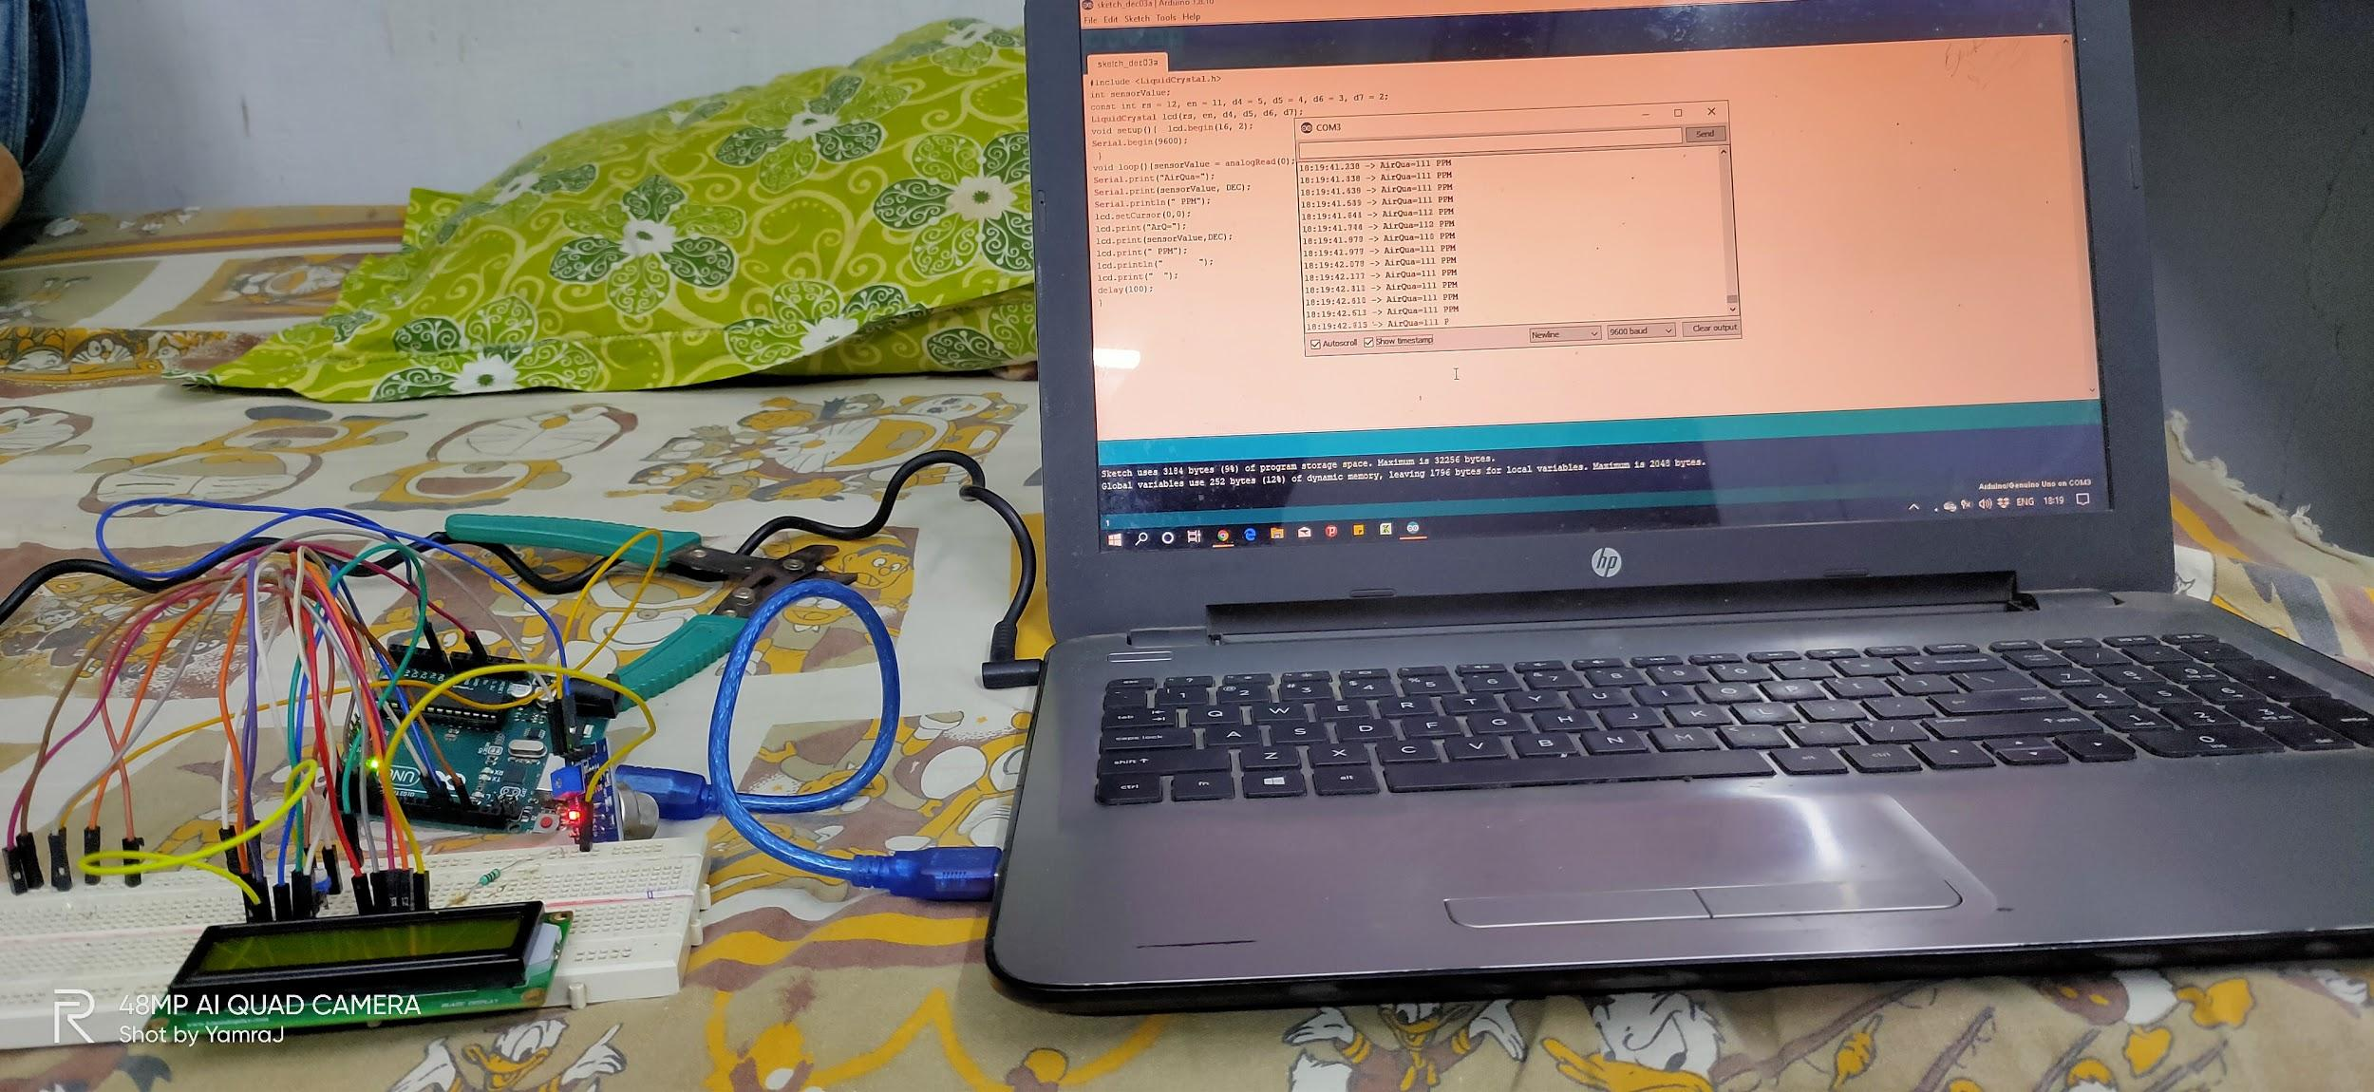

Fig 2.0 Setup of Monitoring System

**4.1 Air Quality Monitoring Equipment**

The equipment shown in Fig.2.1 helps in the acquisition of the data for the various parameters of the environment in which the system is installed.

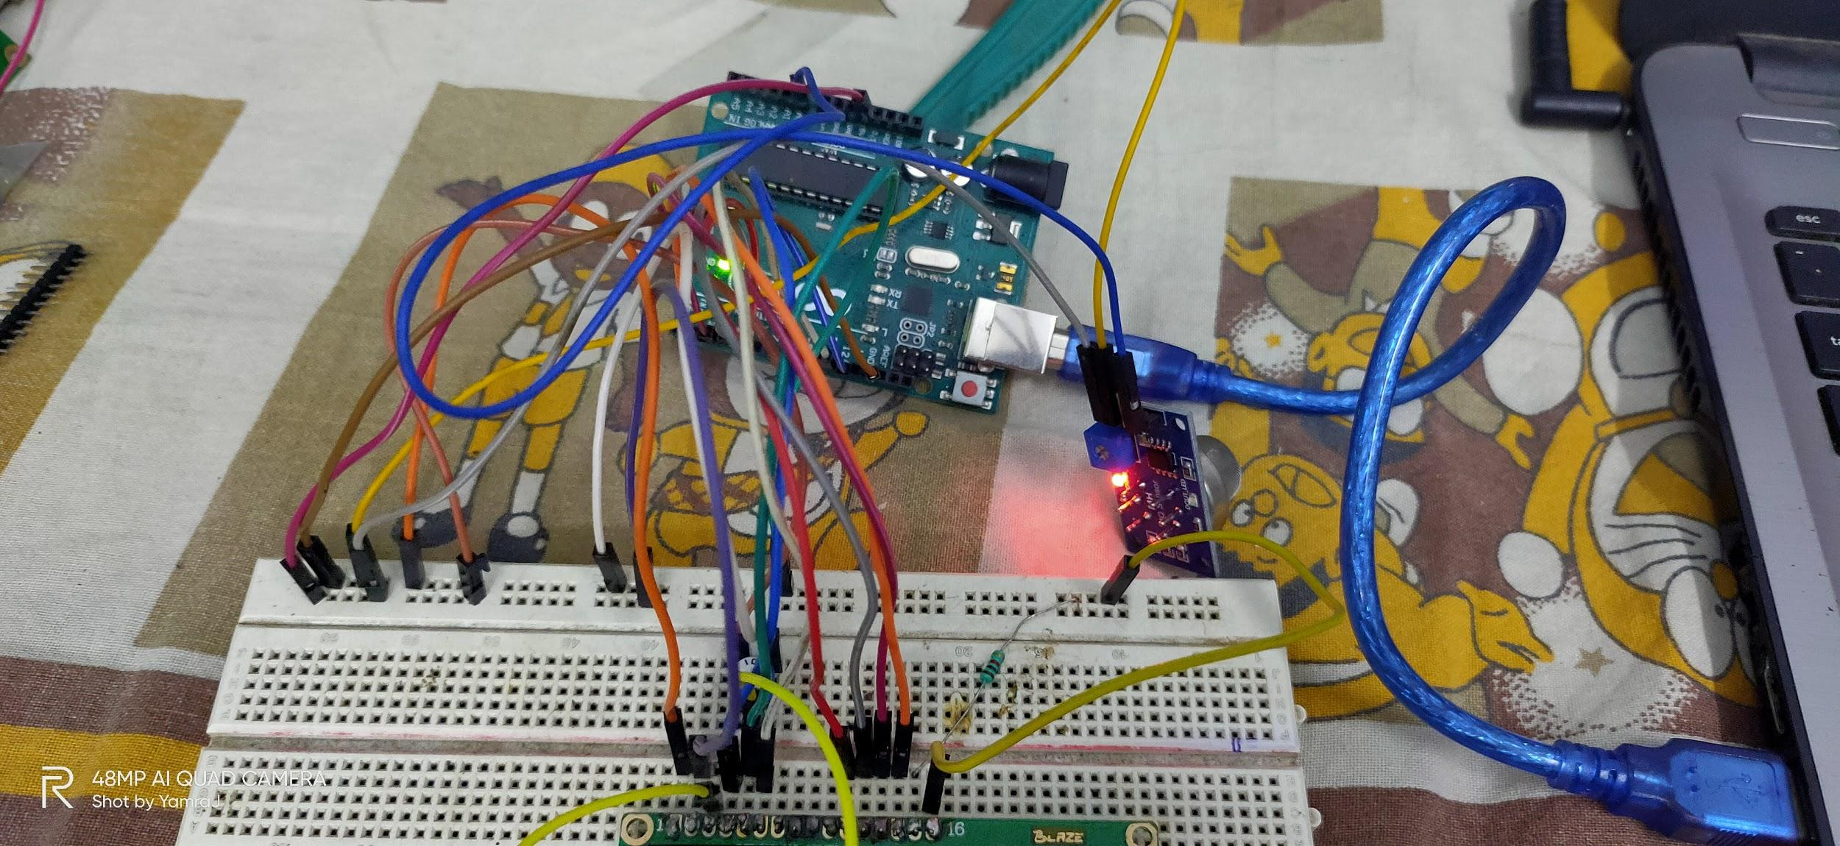

Fig 2.1 Air Quality Monitoring Equipment

The different components of the equipment along with their intended purpose are discussed below:

1. **Arduino Uno R3 microcontroller**:It is the most flexible hardware platform used based on ATmega328P which can be programmed according to the function where it is to be used. It has 6 analog inputs, 14 digital input/output pins (6 pins of these can be used as PWM outputs) , a USB connection, a 16 MHz quartz crystal, SPI, serial interface, a reset button, a power jack and an ICSP header as shown in Fig.2.2.

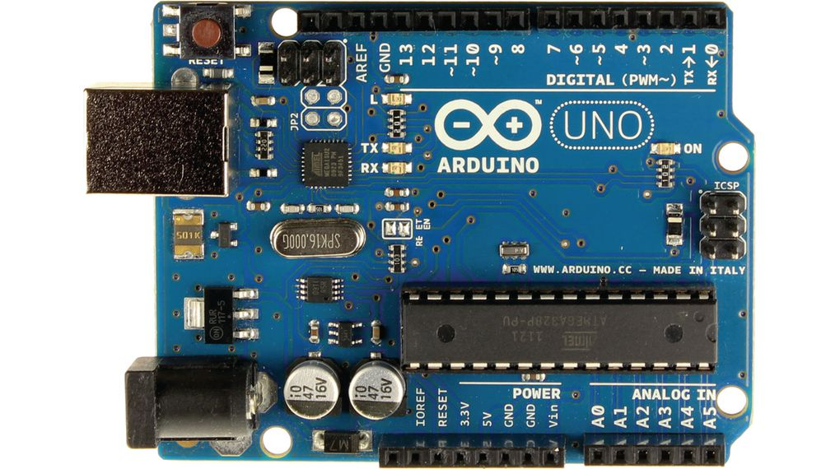

Fig 2.2 Arduino Uno R3 microcontroller

2. **MQ135 Gas Sensor:** The Sensitive material used in MQ135 sensor is SnO2. The conductivity of this material is lower in clean air. The sensor conductivity increases with the increasing concentration of target pollution gas. MQ135 can monitor different kinds of toxic gases such as sulphide, ammonia gas, benzene series steam and CO2. The detection range is 10-10,000 ppm with the voltage rate of about 5.0V±0.1V AC or DC. The important features are long life span, low cost, simple driver circuit and good sensitivity to toxic gases. MQ 135 gas sensor is widely used in industrial gas alarm, portable gas detector and domestic gas alarm as shown below.

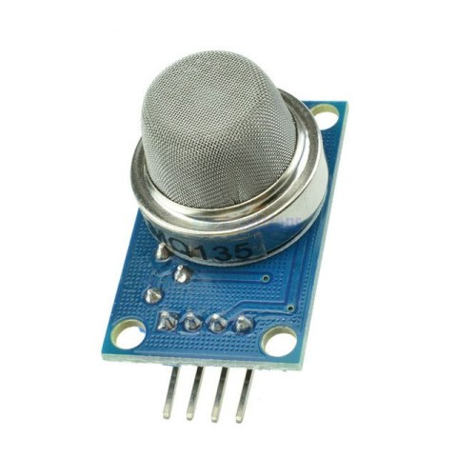

MQ135 is used in this framework for monitoring CO2 in air. The amount of CO2 present in the atmosphere is 400.7 ppm according to which the sensor is calibrated.

**5. Results**

The air quality monitoring system involving gas sensors for monitoring of various parameters has been successfully implemented. The data received from the sensors is displayed on the serial monitor of IDE is shown in Fig 5.0

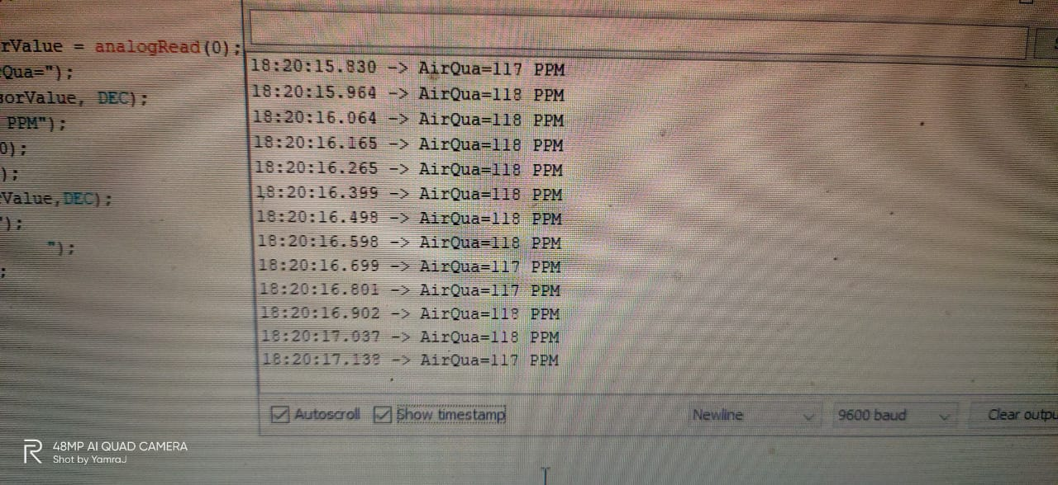

Fig 5.0 Serial Monitor of IDE

The proposed system has been used to test the quality of air in **Indian Institute Of Engineering Science & Technology, Shibpur**. The serial monitors of IDE displays values of Air quality Index in ppm received from the sensors is displayed on the serial monitor of IDE. The values received for the parameters shows that the quality of air in the University environment is good or bad.

**6. Future Aspects**

1.We are going to attach the LED display which will show AQI.

2.We will be increasing number of sensors to increase the accuracy AQI and will be able to additional data also.

3.We will also be displaying concentration of different gases.

**7. CONCLUSIONS**

The system to monitor various parameters of environment using Arduino microcontroller is proposed to improve the quality of air. With the use of technology enhances the process of monitoring various aspects of the environment such as air quality monitoring issue proposed in this report. The detection and monitoring of dangerous gases is taken into account in a serious manner and related precautions have been considered here in the form of an alert message and a buzzer so that the necessary action may be taken. It is estimated that this system will have a great acceptance in the market as it is a centralized system for a complete monitoring function.

**THANK YOU**